LAND USE AND ZONING COMMITTEE AMENDMENT
The Land Use and Zoning Committee offers the following first amendment to File No. 2007-1066:
(1) On page 1, line 11, strike “SUSAN E. HARTMAN” and insert “SS INVESTMENT GROUP LLC”; and
(2) On page 1, line 25 & on page 3, line 16, strike “Susan E. Hartman” and insert “SS Investment Group LLC”; and
(3) On page 4, line 16, after “Category” insert the following:
“ ; provided that commercial uses do not exceed 750,000 square feet, office uses do not exceed 300,000 square feet, industrial uses do not exceed 30 acres, hotel rooms do not exceed 125 rooms, and residential uses do not exceed 1,499 units. However, the Developer may increase or decrease the amount of a particular land use within the approved development program without triggering further land use or traffic review subject to compliance with the following conversion table:
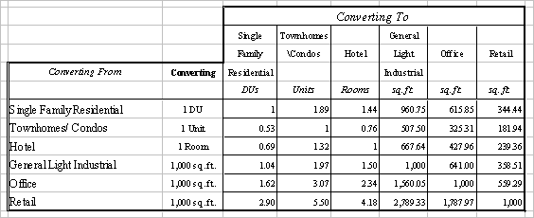” ; and
(4) Amend the introduction to reflect this Amendment.

Form Approved:

/s/ Shannon K. Eller_____________
Office of General Counsel

Legislation Prepared By: Shannon K. Eller

/tmp/in/input.doc

